**Practical 5: Build Your DB Server and Interact with Your DB Using an App**

**Solution:**

Step 1: Go to your Dashboard and select the service named “VPC”

Step 2: In left side navigation bar select security group and click on create security group

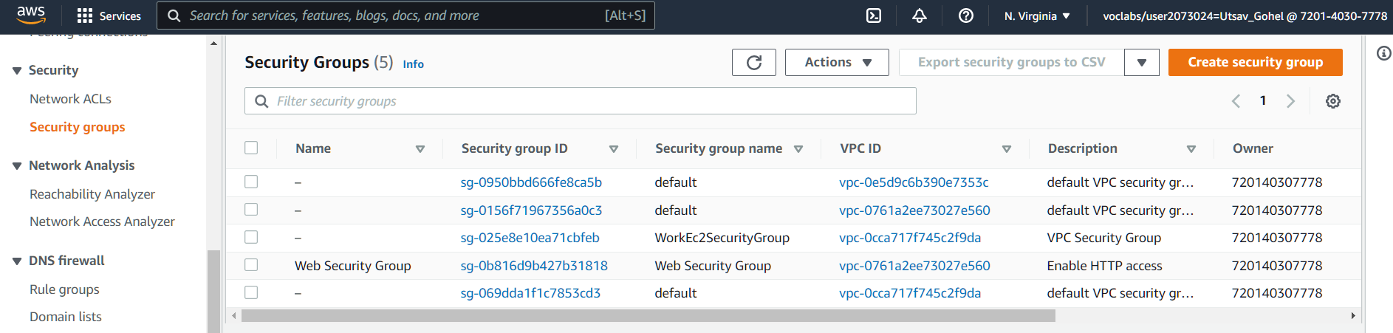

Step 3: Configure the security group

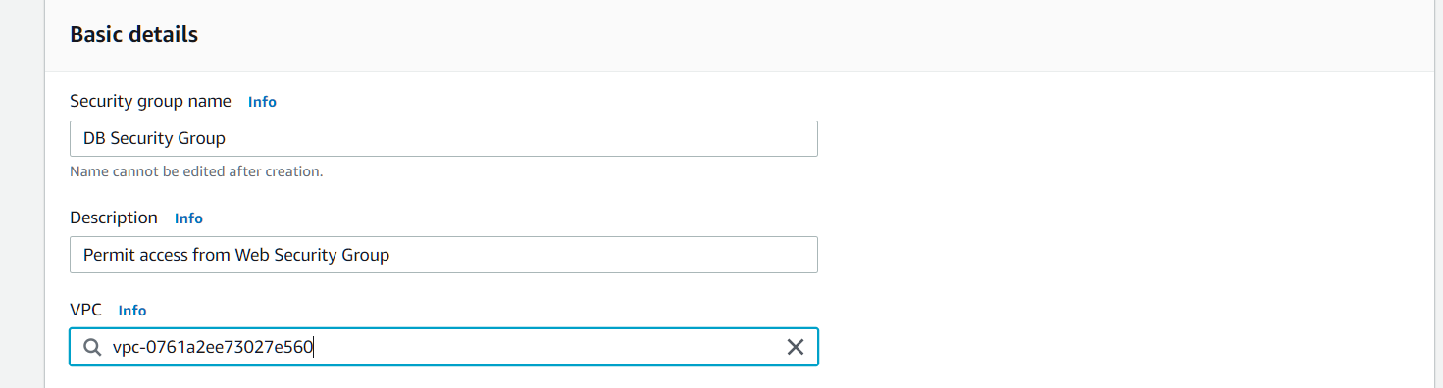

Step 4: Add inbound rule and click on create security group

Type: MySQL/Aurora (3306)

CIDR, IP, Security Group or Prefix List: Type sg and then select Web Security Group.

**Section 2 : Create a DB Subnet Group**

Step 1: From service select “RDS”

Step 2: From navigation select subnet group and create and configure subnet group

Step 3:

Scroll down to the Add Subnets section. Expand the list of values under Availability Zones and select the first two zones: us-east-1a and us-east-1b. Expand the list of values under Subnets and select the subnets associated with the CIDR ranges 10.0.1.0/24 and 10.0.3.0/24. These subnets should now be shown in the Subnets selected table. Choose Create

**Section 3: Create an Amazon RDS DB Instance**

Step 1: We will configure and launch a Multi-AZ Amazon RDS for MySQL database instance.

Step 2: In the left navigation pane, choose Databases. Choose Create database

If you see Switch to the new database creation flow at the top of the screen, please choose it.

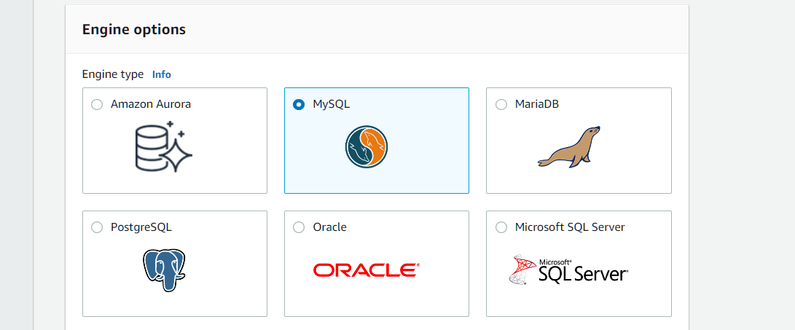

Step 3: Under Settings, configure:

DB instance identifier: lab-db

Master username: main

Master password: lab-password

Confirm password: lab-password

Under DB instance class, configure:

Select Burstable classes (includes t classes).

Select db.t3.micro

Under Storage, configure:

Storage type: General Purpose (SSD)

Allocated storage: 20

Under Connectivity, configure:

Step 4: Expand Additional configuration, then configure:

Initial database name: lab

Uncheck Enable automatic backups.

Uncheck Enable encryption

Uncheck Enable Enhanced monitoring.

Step 5: Create Database

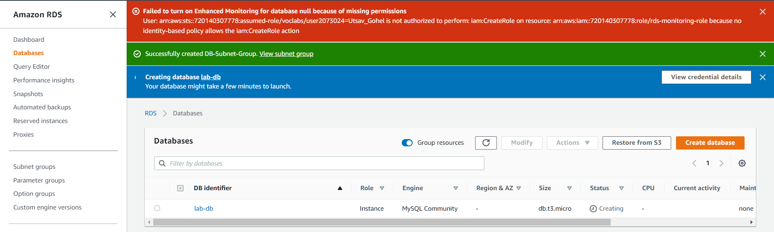

**Section 4: Interact with Your Database**

Step 1: Endpoint: Paste the Endpoint you copied to a text editor earlier

Database: lab

Username: main

Password: lab-password

Choose Submit